**Unit Testing**

**Make a Booking**

**Unit Test Result- Successful**

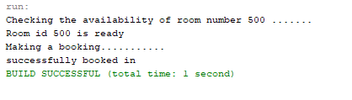

**Make a Booking a room at the same time**

**Unit Test Result- Failed**

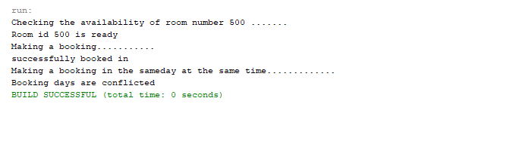

**Make a checkin**

**Unit Test Result- Successful**

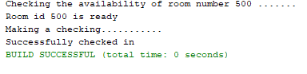

**Make a Checking with conflicting stay days**

**Unit Test Result- Failed**

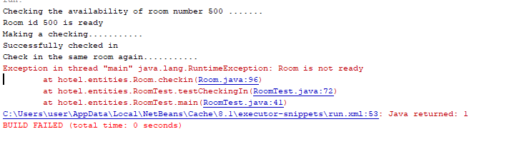

**Make a Checkout**

**Unit Test Result : Successful**

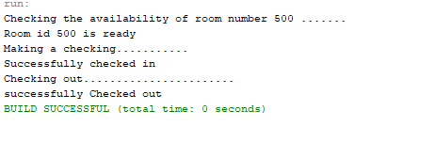

**Checkout a non-occupied room**

**Unit Test Result- Failed**

